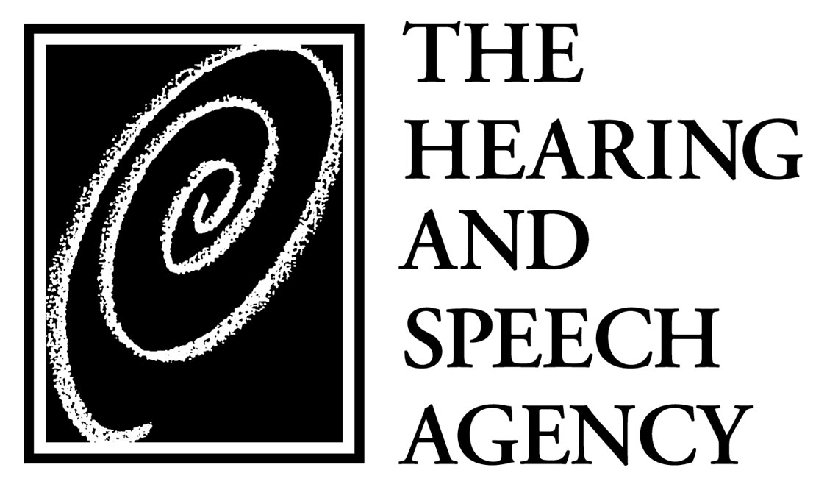

COMMUNICATING HOPE

PLEDGE

I/We am/are pleased to pledge $ ___________________ to The Hearing and Speech Agency’s Communicating Hope campaign, the purpose of which is to acquire land, construct and furnish a new facility at Seton Business Park, and to sustain the Agency and its mission.

I/We plan to pay the pledge:

ڤ In full by December 31, 2004.

ڤ In ______ (number) annual installments by _______(month/year).

_____________________________________________________________________
Name(s) as should appear in campaign reports and other Agency publications.

________________________________ __________________________
Signature(s) Date

Please return to the Director of Development, The Hearing and Speech Agency, 5900 Metro Drive, Baltimore, MD 21218. Pledges may be paid by cash, check, credit card or gifts of stock. Please call the Development Office, 410.318-6780, for instructions on making gifts of stock for our audited financial statements or if you have any questions. The Hearing and Speech Agency is a 501(c)(3) nonprofit organization; donations are, therefore, tax-deductible to the fullest extent of the law. Documents submitted by The Hearing and Speech Agency to the State of Maryland under the Maryland Charitable Solicitations Act are available from the Office of the Secretary of State for the cost of copying and postage.

